SNS Addiction Level Prediction System
Deep Learning Analysis Report

TabResNet-based Social Media Addiction Prediction Model

Developer | lightgo
Email | lightgo1230@gmail.com
Date | 2026
Version | v1.0

1. Project Overview
This project is a deep learning system that analyzes social media user behavior data to predict SNS addiction levels on a scale of 1 to 10. It uses a PyTorch-based TabResNet architecture and a native Windows GUI built with Rust + egui, collecting user information through a chat-style interface to analyze addiction levels in real time.

1.1 Key Features
Item | Description
Dataset | 25,000 social media user behavior records
Model | TabResNet (Embedding + Pre-Activation Residual Blocks)
Features | 16 categorical + 17 numerical + 9 boolean = 42 total
Target | addiction_level_1_to_10 (continuous regression, 1-10)
GUI | Rust + egui 0.29 native Windows application
Interface | 12-question chat-style Q&A for addiction level prediction

2. Dataset
File: social_media_user_behavior.csv | Source: Kaggle | Size: 25,000 rows x 45 columns

2.1 Feature Composition
Type | Count | Examples
Categorical | 16 | gender, primary_platform, country, occupation, education_level ...
Numerical | 17 | daily_screen_time_minutes, followers_count, sleep_hours_per_night ...
Boolean | 9 | is_content_creator, checks_phone_first_morning, follows_influencers ...
Target | 1 | addiction_level_1_to_10

2.2 Preprocessing
Type | Method
Categorical | LabelEncoder -> integer index -> Embedding Layer input
Numerical | StandardScaler normalization (mean=0, std=1)
Boolean | Cast to 0 / 1 float
Split | Train 70% / Validation 10% / Test 20%

3. Model Architecture - TabResNet
TabResNet is a custom residual neural network designed for tabular data. It applies Entity Embeddings to categorical variables and uses Pre-Activation Residual Blocks for stable deep network training.

3.1 Architecture Details
Component | Description
Embedding Layer | Each categorical column -> min(50,(n+1)//2) dimensional dense vector
Embedding Concat | All embedding vectors + numerical features concatenated
Input Projection | Linear(input_dim -> 256) + BatchNorm + ReLU
Residual Block x 4 | BN->ReLU->Linear(256->256)->BN->ReLU->Dropout(0.3)->Linear + Skip
Output Head | Linear(256->128) -> ReLU -> Linear(128->1)
Total Parameters | 559,832

3.2 Training Configuration
Setting | Value
Optimizer | AdamW (lr=1e-3, weight_decay=1e-4)
Loss Function | MSELoss (Mean Squared Error)
Scheduler | ReduceLROnPlateau (factor=0.5, patience=5)
Batch Size | 64 (train) / 256 (val & test)
Max Epochs | 30
Early Stopping | patience=10
Best Epoch | 8

4. Performance Evaluation

4.1 Quantitative Metrics
Metric | Value | Description
RMSE | 1.1066 | Lower is better - root mean squared error
MAE | 0.8851 | Lower is better - mean absolute error
R2 | 0.5777 | Higher is better - explained variance ratio
Exact Match | 34.2% | Exact match after rounding
+/-1 Accuracy | 64.7% | Error within +/-1
+/-2 Accuracy | 93.1% | Error within +/-2
+/-3 Accuracy | 98.9% | Error within +/-3

5. Analysis Graphs

5.1 Learning Curve
Train and Validation RMSE per epoch, with the best epoch marked.
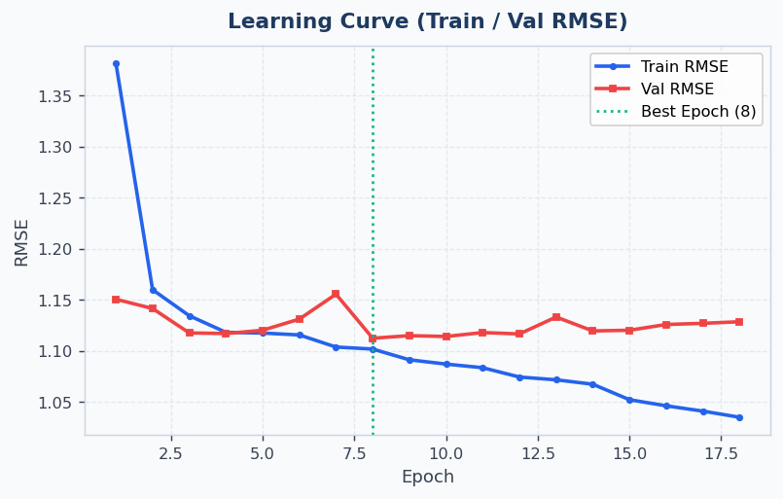

5.2 Actual vs Predicted Scatter Plot
Comparison of actual and predicted addiction levels for 1,200 test samples. Color indicates absolute error.
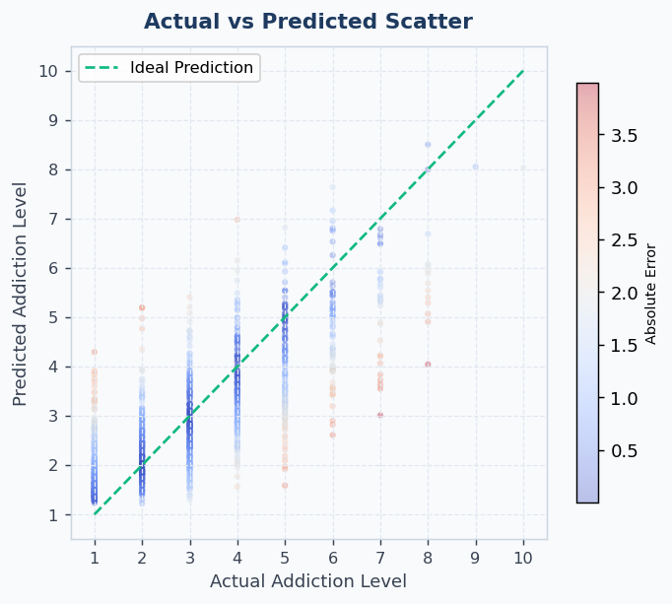

5.3 Level Distribution Comparison
Actual vs predicted sample counts at each addiction level (1-10).
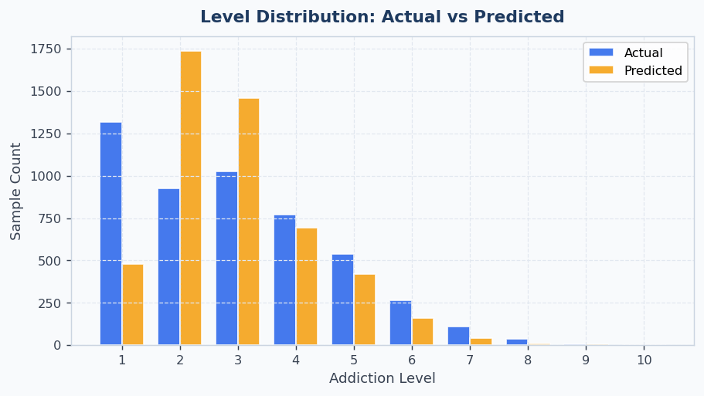

5.4 Residual Distribution
Histogram of prediction errors. A well-calibrated model concentrates errors near zero.
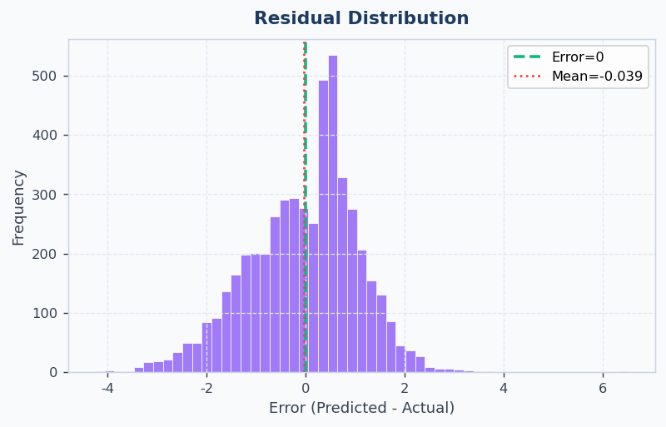

5.5 Absolute Error by Level (Boxplot)
Boxplot of absolute errors grouped by actual addiction level.
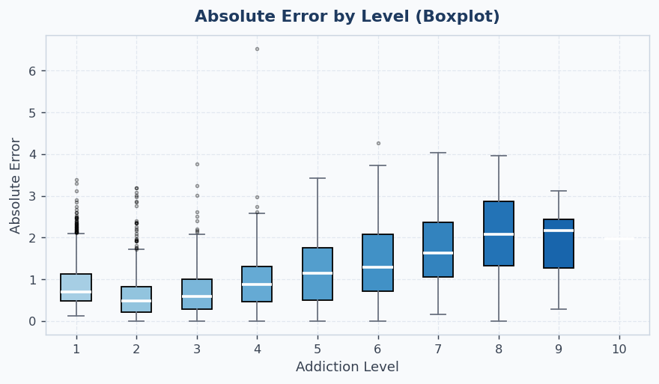

5.6 Accuracy by Error Tolerance
Accuracy for exact match, within +/-1, +/-2, and +/-3 tolerance.
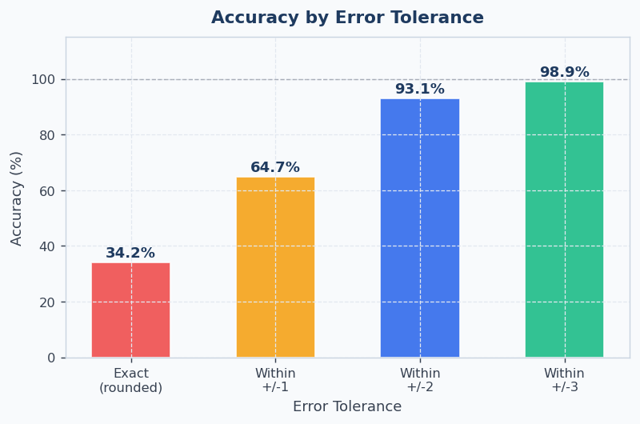

6. Addiction Level Reference
Level | Label | Description
1 - 2 | Very Low | Very healthy social media usage. Keep your balanced lifestyle.
3 - 4 | Low | Healthy usage level. Maintain your current pattern.
5 - 6 | Moderate | Caution advised. Check your screen time regularly.
7 - 8 | High | Addiction warning signs. Digital detox and limits recommended.
9 - 10 | Very High | Severe addiction. Professional counseling strongly recommended.

7. Tech Stack
Area | Technology
GUI | Rust + egui 0.29 + eframe 0.29
Deep Learning | Python + PyTorch
Data Processing | pandas, numpy, scikit-learn
Visualization | matplotlib
Report | python-docx
Icon Embedding | winres 0.1

